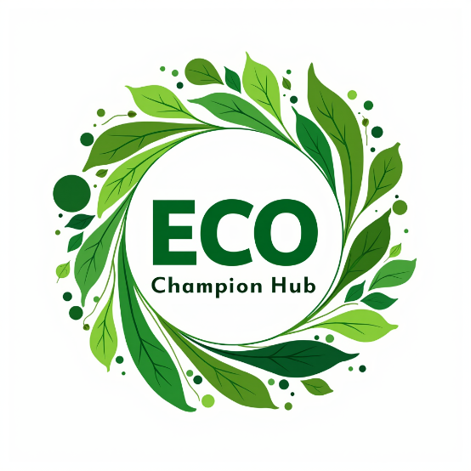

**Eco-Champion Hub**

**A Sustainable Development Initiative**

Visit our website : <https://eco-champion-hub.netlify.app/>

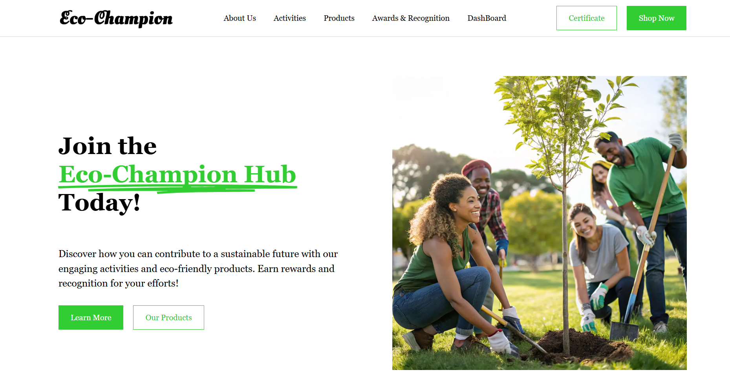**Introduction :**

Eco-Champion Hub is an innovative platform designed to encourage sustainable development by incentivizing individuals to actively participate in eco-friendly initiatives. Users earn reward points for actions such as planting trees, cleaning the environment, and conserving resources, which can then be redeemed for discounts on eco-friendly products. The platform also hosts annual award events to further motivate participants and recognizes top contributors with prizes and certifications.

**Problem Statement & Solutions :**

**Problem 1: Lack of Public Engagement in Sustainable Development(40% - 50%)**

**Issue:** Many individuals are reluctant to participate in sustainability efforts due to a lack of motivation and tangible benefits.( They are not moving forward)

**Solution:** Eco-Champion Hub rewards users with points for verifiable eco-friendly activities, fostering greater engagement.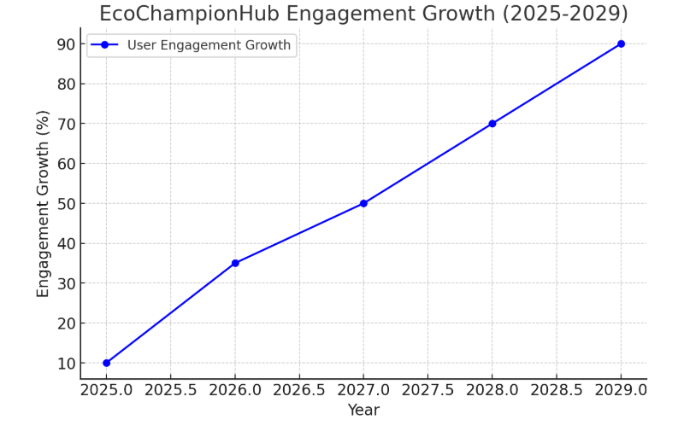

**Problem 2: Limited Incentives for Widespread Participation(60% - 75% )**

**Issue:** Even with discounts, many people may not be willing to participate in sustainable activities.  
**Solution:** The platform organizes an annual awards event with cash prizes and certificates for top contributors, enhancing motivation.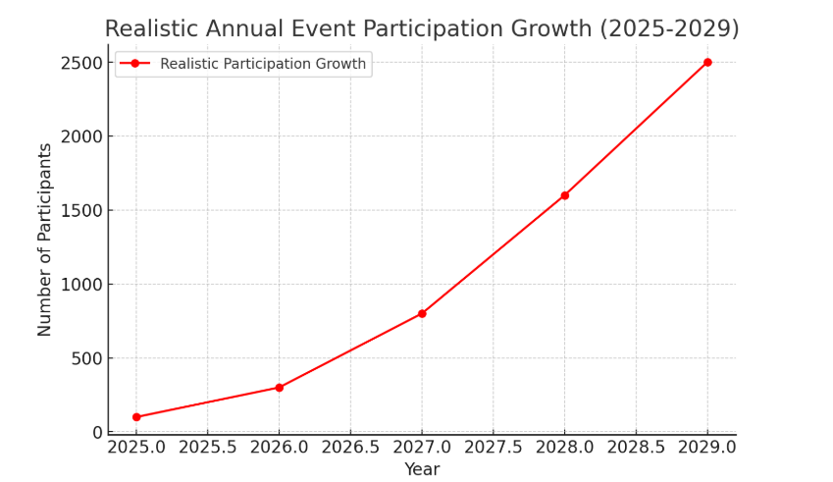

**Problem 3: Competition with Large E-Commerce Platforms(70% - 85%)**

**Issue:** Users may prefer established e-commerce platforms over Eco-Champion Hub.  
**Solution:** The platform offers significantly reduced product prices, prioritizing sustainability over profit. The generated revenue is reinvested into community incentives.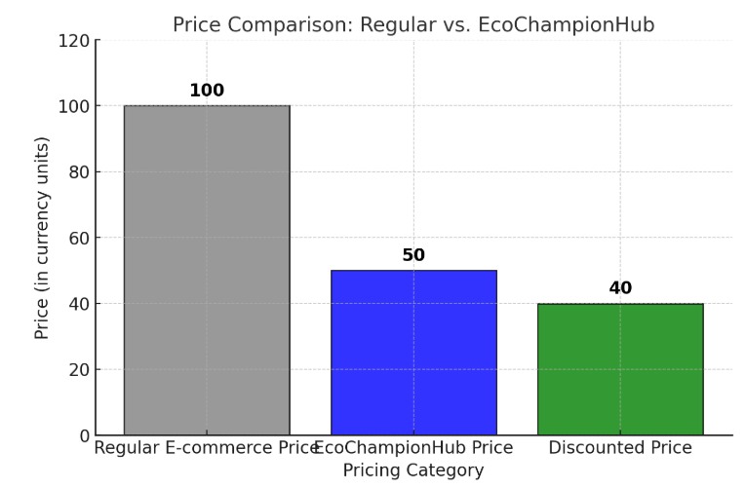

**Problem 4: Student Engagement in Sustainability(50% - 80%)**

**Issue:** Many students are unaware of or uninterested in sustainability initiatives.  
**Solution:** Students who participate receive verified certificates that enhance their job prospects and

career growth.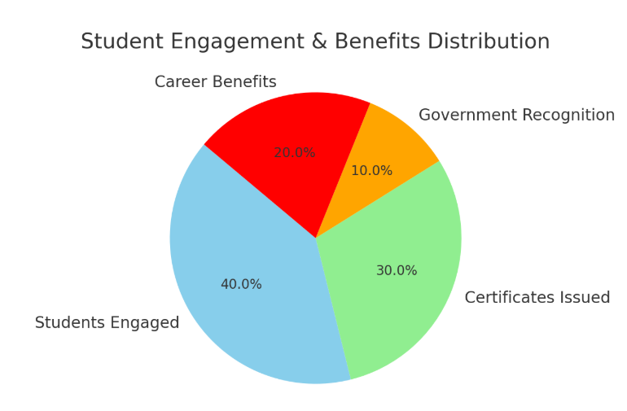

**Problem 5: Waste Management Plan (70% - 96%)**

Problem, people does not have food to eat. So if we give any task for them, they will do something.

Solution, we will provide instead of waste management, if they take any particular 1 kg of plastic or another something which is to have, we will give instead of 1 kg, we will provide 1 kg of fruits.

We are Focus on This all

**1. SDG 1 – No Poverty: Providing food in exchange for waste collection directly supports people in need.**

**2. SDG 2 – Zero Hunger: Ensures food security for those who cannot afford it.**

**3. SDG 3 – Good Health & Well-being: Access to nutritious food improves overall health.**

**4. SDG 10 – Reduced Inequalities: Helps bridge economic disparities by supporting marginalized communities.**

**5. SDG 12 – Responsible Consumption & Production: Encourages sustainable waste management and recycling.**

**3. Business Model & Revenue Strategy**

Eco-Champion Hub’s business model is structured around a **social enterprise framework** that balances sustainability with financial stability.

* **Revenue Streams:**
  + **Eco-Friendly Product Sales** – Products are sourced at wholesale prices and sold with minimal markup.
  + **Partnerships & Sponsorships** – Collaborations with NGOs, government programs, and green businesses.
  + **Corporate Social Responsibility (CSR) Funding** – Companies contribute to the initiative as part of their sustainability goals.
* **Financial Viability:**
  + Example: If a product is sourced for **₹30** and sold for **₹50** (after discounts), the profit margin ensures continued operational sustainability.
  + Annual awards and verification teams are funded through **sales and sponsorship revenue**.

**4. Sustainable Development Goals (SDGs) Alignment**

Eco-Champion Hub aligns with the **United Nations’ Sustainable Development Goals (SDGs):**

* **SDG 6** – Clean Water & Sanitation (Water conservation initiatives)
* **SDG 11** – Sustainable Cities & Communities (Eco-friendly urban activities)
* **SDG 12** – Responsible Consumption & Production (Encouraging eco-friendly product use)
* **SDG 13** – Climate Action (Engagement in environmental restoration activities)

**5.Real-World Examples & Legal Frameworks**

**Existing Platforms & NGOs**

* **greenApes** – A digital platform that rewards individuals for engaging in sustainable behaviors through a gamified approach, allowing them to earn points and redeem eco-friendly rewards.
* **AAA's Eco-Friendly Discounts** – A sustainability initiative by the American Automobile Association (AAA) that offers discounts and incentives for members who choose green transportation or eco-friendly products.
* **Copenhagen's CopenPay Program** – A city-led initiative in Copenhagen where citizens can earn discounts and rewards for using sustainable transport, such as biking or public transit, to promote eco-conscious urban living.

**Relevant Legal Acts & Court Judgments**

* **Environmental Protection Act, 1986** (India) – Supports sustainable initiatives.
* **Corporate Social Responsibility (CSR) Law, Companies Act 2013** – Encourages corporate funding for environmental projects.

**6. Challenges & Risk Mitigation**

|  |  |  |  |
| --- | --- | --- | --- |
| **Challenges** | **Mitigation Strategies** |  |  |
| Fake submissions | AI-based verification & manual review |  |  |
| Financial sustainability | Revenue diversification through sponsorships & partnerships |  |  |
| Competition from e-commerce | Unique reward-based engagement strategy |  |  |

| **7. Conclusion & Future Scope** |  |
| --- | --- |
|  |  |
| Eco-Champion Hub is a scalable and impactful platform that encourages individuals and businesses to actively participate in sustainability efforts. With a well-structured incentive system and strong community engagement, it has the potential to drive significant environmental change. Future enhancements include **expansion into mobile applications**, and **global partnerships for sustainability initiatives**. |  |
|  |  |